|  |  |
| --- | --- |
| **Ex. No. 3** | **RESPONSIVE WEBPAGE USING HTML5 AND CSS3** |
| **Date of Exercise** | 09/01/2023 |

**Aim**

To build a responsive webpage using html5, css with our own contents and images

**Description**

The styling to a webpage can be done using 3 ways

→In line within the tag as an attribute [style=""]

→Internal within the html document within style tag

→External linked with the help of link tag. <style>...</style>

Selectors: >> Used to add styling in the webpage. The following are the different types of selectors available in CSS.

1. Universal selector: To apply to entire webpage, [Syntax: * {…}]
2. Type Selector: To apply to specific tags based on its name, [Syntax: <tagname> {…}]
3. Class Selector: To apply to set of tags, [Syntax: .<class_name> { …} ]
4. Id Selector: To apply to a unique specific tag, [Syntax: <id_name> {…}]
5. Grouping Selector: To apply to set of tags, classes, id’s [Syntax: <id_name>, <tagname> {…} etc..,]
6. Child selector: To apply to direct child of a tag [Syntax: <tagname> > <tagname> {…}]
7. Descendent Selector: This applies to all child of a tag
8. Adjacent Sibling Selectors: to apply only to the adjacent sibling elements.
9. General sibling selector: to apply to all the sibling elements.
10. Attribute Selector: to apply based on attribute value pai
11. Query Selector: Using script basically JavaScript is used

Following are some of the css properties: -

* margin: to set the marginal vale [px, pt. %]
* color: to add color to the font color [names, rgb, hex]
* background-color: to add background color [names, rgb, hex]
* height: for adding the height of the element space.
* background-image: to add an image
* background-repeat: to add the image in repetition
* background-size: for the setting up of background size
* position: for setting op of the position of the elements
* float: For making the element in floating
* opacity: for transparent property

**Program**

<!DOCTYPE html>

<!DOCTYPE html>

<html lang="en">

<head>

<meta charset="UTF-8">

<meta http-equiv="X-UA-Compatible" content="IE=edge">

<meta name="viewport" content="width=device-width, initial-scale=1.0">

<title>KKNPP Inplant Trainning Experience</title>

<style>

* {

margin: 0%;

}

#header {

background-color: rgb(186, 161, 129);

color: brown;

text-align: center;

font-weight: bolder;

font-size: x-large;

font-family: 'Franklin Gothic Medium', 'Arial Narrow', Arial, sans-serif;

width: 100%;

}

#header:hover {

background-color: brown;

color: rgb(186, 161, 129);

}

.bground {

width: 100%;

height: 350px;

background-image: url("Units.png");

background-repeat: no-repeat;

background-position: center;

background-size: 100% 350px;

}

#about-kknpp h4 {

text-align: center;

padding-bottom: 1%;

}

#about-kknpp {

text-align: justify;

margin: 1%;

padding: 2%;

background-color: lightgrey;

}

#imgs {

background-color: white;

display: block;

}

#img1, #img2, #img3 {

width: 33%;

height: 150px;

float: left;

opacity: 0.7;

}

#img1 {

background-image: url("Atom.png");

background-repeat: no-repeat;

background-position: center;

background-size: 60% 100%;

}

#img2 {

background-image: url("NPCIL.png");

background-repeat: no-repeat;

background-position: center;

background-size: 60% 100%

}

#img3 {

background-image: url("Fission.png");

background-repeat: no-repeat;

background-position: top;

background-size: 100% 165px;

}

#img1:hover, #img2:hover, #img3:hover {

opacity: 1.0;

}

#img1 span {

display: block;

text-align: center;

position: inherit;

top: 1%;

font-size: larger;

font-weight: bolder;

color: darkgreen;

background-color: lightyellow;

opacity: inherit;

}

#img1 span {

opacity: 1.0;

}

#kknpp_it, #kknpp_server {

display: inline-block;

width: 100%;

background-color: aquamarine;

/*height: 200px;*/

}

div[id="kknpp_it_content"] {

text-align: justify;

width: 44%;

float: left;

margin: 3%;

}

#kknpp_it>img {

height: inherit;

width: 50%;

float: left;

height: inherit;

}

div[id="kknpp_server_content"] {

text-align: justify;

width: 44%;

float: right;

margin: 3%;

}

#kknpp_server>img {

width: 50%;

float: left;

height: inherit;

}

</style>

</head>

<body>

<div id="header">Inplant Training Experience at Kudankulam Nuclear Power Plant</div>

<div class="bground"></div>

<div id="about-kknpp">

<h4>About KKNPP</h4>

<p>There is a huge demand for the electricity, in order to meet the demand of Tamil Nadu and the other southern states, Nuclear Power Corporation of India Limited(NPCIL) has set up two nuclear power reactors each with capacity of 1000MW of VVER type

(Russian abbreviation for “Water Water Energy Reactor” means reactors are water cooled and water moderated) and planned to setup for even 4 more of VVER type for that the construction work is started on the coastal area of Kudankulam, Tirunelveli

District, Tamil Nadu setup with technical and financial assistance of Russian Federation. Unit 1 and 2 construction work was started on 31st of March 2002, and faced a several delays due to opposition from the local fisherman. Budgeted cost

for the two units was 13,171 crores later it was revised to 17,270 crores and Russia gave an advanced credit of 6,416 crores for both the units. Unit 1 had completed its construction work and started working and on 22nd of October 2013 it

is synchronized to southern power grid and unit 2 on 29th of August 2016.</p>

</div>

<div>

<div id="img1"><span>Atom</span></div>

<div id="img2"></div>

<div id="img3"></div>

</div>

<div id="kknpp_it">

<div id="kknpp_it_content">

<h3>IT inside KKNPP</h3>

<p>Inside the Kudankulam Nuclear Power Plant, Information Technology department is classified into three parts as follows, Hardware, Software and Networking With the help of Hardware and hardware devices required software and applications are

made and that is distributed and shared with the other peoples in the organization using Networking each one is carried out by a special team and they are having a head for each team separately.</p>

</div>

<img src="it.png" alt="IT image" width="50%" height="50%">

</div>

<div id="kknpp_server">

<div id="kknpp_server_content">

<h3>Servers in KKNPP</h3>

<p>Operating systems used in the servers are Windows Server 2019, Red hat and Cent OS where in Red Hat some of the packages are to be pay in order to get it. Servers used are as follows: SMB, DHCP, DNS, IMAP, POP3, SMTP etc.,</p>

</div><img src="server.png" alt="Server Image">

</div>

</body>

</html>

**Output**

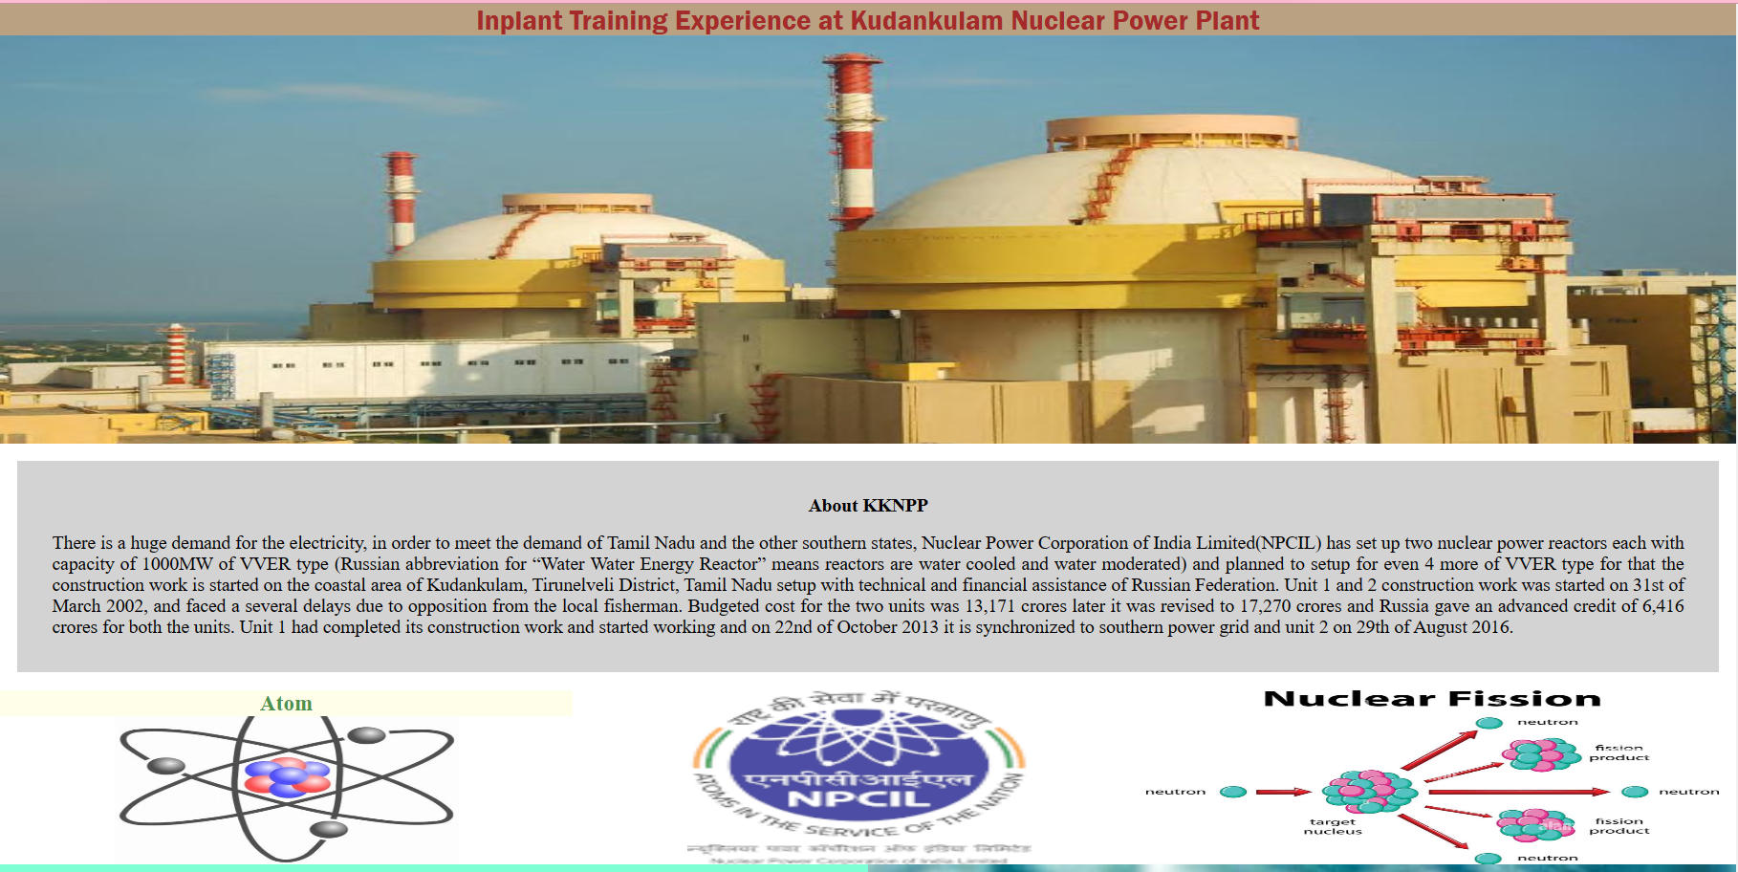

**Result**

Building up of a responsive webpage with our own content and images has been completed successfully and the webpage is rendered displayed by the browser.